END OF CHAPTER ASSIGNMENT 8

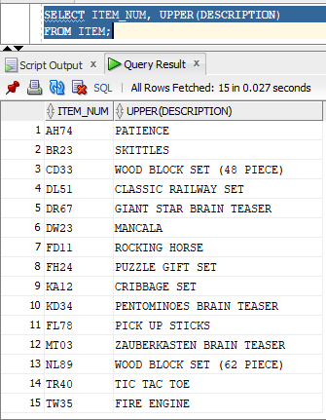

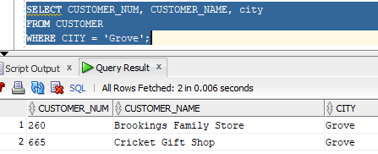

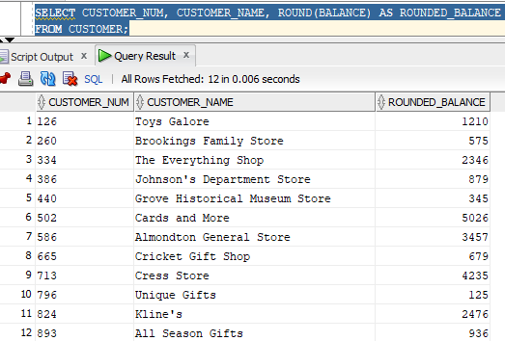

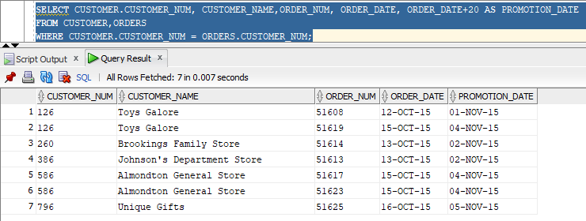

A)CREATE OR REPLACE PROCEDURE DISP_CUSTOMER_NAME(I_CUSTOMER_NUM IN CUSTOMER.CUSTOMER_NUM%TYPE) AS

I_CREDIT_LIMIT customer.credit_limit%TYPE;

I_CUSTOMER_NUM CUSTOMER.CUSTOMER_NUM%TYPE;

BEGIN

SELECT CUSTOMER_NAME, CREDIT_LIMIT

INTO I_customer_name, I_CREDIT_LIMIT

FROM CUSTOMER

WHERE CUSTOMER_NUM = I_CUSTOMER_NUM;

DBMS_OUTPUT.PUT_LINE(I_CUSTOMER_NUM);

DBMS_OUTPUT.PUT_LINE(I_CREDIT_LIMIT);

END;/

b) CREATE OR REPLACE PROCEDURE DISP_CUST_ORDERS (I_ORDER_NUM IN ORDERS.ORDER_NUM%TYPE) AS

I_ORDER_NUM ORDERS.ORDER_NUM%TYPE;

I_ORDER_DATE ORDERS.ORDER_NUM%TYPE;

I_CUSTOMER_NUM CUSTOMER.CUSTOMER_NUM%TYPE;

I_CUSTOMER_NAME CUSTOMER.CUSTOMER_NAME%TYPE;

BEGIN

SELECT ORDERS.ORDER_NUM, ORDER_DATE, CUSTOMER.CUSTOMER_NUM, CUSTOMER_NAME

FROM ORDERS, CUSTOMER

WHERE ORDERS.CUSTOMER_NUM = CUSTOMER.CUSTOMER_NUM;

DBMS_OUTPUT.PUT_LINE(I_ORDER_NUM);

DBMS_OUTPUT.PUT_LINE(I_ORDER_DATE);

DBMS_OUTPUT.PUT_LINE(I_CUSTOMER_NUM);

DBMS_OUTPUT.PUT_LINE(I_CUSTOMER_DATE);

END;

/

c)

d) CREATE OR REPLACE PROCEDURE DISP_CUST_ORDERS(I_ORDER_NUM IN ORDERS.ORDER_NUM%TYPE,

I_ORDER_DATE IN ORDERS.ORDER_DATE%TYPE) AS

BEGIN

UPDATE ORDERS

SET ORDER_DATE = I_ORDER_DATE

WHERE ORDER_NUM = I_ORDER_NUM;

END;

/

e) CREATE OR REPLACE PROCEDURE DISP_CUST_ORDERS(I_ORDER_NUM IN ORDERS.ORDER_NUM%TYPE) AS

BEGIN

DELETE

FROM ORDER_LINE

WHERE ORDER_NUM = I_ORDER_NUM;

BEGIN

DELETE

FROM ORDERS

WHERE ORDER_NUM = I_ORDER_NUM;

END;

/

6) CREATE OR REPLACE PROCEDURE DISP_ITEM_ORDS (I_CATEGORY IN ITEM.ITEM_NUM%TYPE) AS

I_ITEM_NUM ITEM.ITEM_NUM%TYPE;

I_DESCRIPTION ITEM.ITEM_NUM%TYPE;

I_STOREHOUSE_NUM ITEM.ITEM_NUM%TYPE;

I_PRICE ITEM.ITEM_NUM%TYPE;

CURSOR ORDSGROUP IS

SELECT ITEM.ITEM_NUM, DESCRIPTION, STOREHOUSE_NUM, PRICE

FROM ITEM

WHERE ITEM_NUM = I_ITEM_NUM;

BEGIN

OPEN ORDSGROUP;

LOOP

FETCH ORDSGROUP INTO I_ITEM_NUM,I_DESCRIPTION,I_STOREHOUSE_NUM,I_PRICE;

EXIT WHEN ORDSGROUP%NOTFOUND;

DBMS_OUTPUT.PUT_LINE(I_ITEM_NUM);

DBMS_OUTPUT.PUT_LINE(I_DESCRIPTION);

DBMS_OUTPUT.PUT_LINE(I_STOREHOUSE_NUM);

DBMS_OUTPUT.PUT_LINE(I_PRICE);

END LOOP;

CLOSE ORDSGROUP;

END;

/

7)a) strSQL = “DELETE FROM ORDERS WHERE ORDER_NUM = ‘”

StrSQL = strSQL & I_ORDER_NUM

StrSQL = strSQL & “’”

DoCmd.RUNSQL strSQL

END FUNCTION (?)

b)Public Function RepUpdate(I_ORDER_DATE, I_ORDER_NUM)

Dim StrSQL As String

StrSQL=”UPDATE ORDERS SET ORDER_DATE = ‘”

StrSQL= strSQL & I_ORDER_DATE

StrSQL= strSQL & ‘ WHERE I_ORDER_NUM = ‘”

StrSQL= strSQL & ORDER_NUM

StrSQL= strSQL & “’”

DoCmd.RunSQL strSQL

End Function(?)

8) CREATE OR REPLACE PROCEDURE ITEM_PRICE (I_ITEM_NUM IN ITEM.ITEM_NUM%TYPE,

I_PRICE IN ITEM.PRICE%TYPE) AS

BEGIN

UPDATE ITEM

SET PRICE = I_PRICE

WHERE CATEGORY = I_CATEGORY

END;

/

BEGIN

ITEM_PRICE(26.95, ‘AH74’)

END;

/

9) CREATE OR REPLACE TRIGGER ADD_CUSTOMER_BALANCE

AFTER INSERT ON REP FOR EACH ROW

BEGIN

UPDATE REP

SET ON_REP =ON_COMMISSION * :NEW.BALANCE

WHERE REP.REP_NUM = CUSTOMER.REP_NUM

10) The MONTHSBETWEEN function is used to obtain the number of months between two inputted dates. If date one is later than date two, the result equals positive. If both dates are around the same time the result is an integer. The CURRENTDATE function returns the current datetime in the user’s timezone. SYSDATE returns the current date and time of the database server with a time zone that may differ. SQL SERVER- GETDATE() ACCESS- SELECT DATE.

a) SELECT ORDER_NUM, SYSDATE AS TODAYS DATE, ORDER_DATE, ROUND(SYSDATE – ORDER_DATE, 2) AS DAYS PAST

FROM ORDERS;

b) In access, Date() is used when dates are required. Now() is used for datetime values.